**Women at UCL: Presence and Absence - The Main Exhibition**

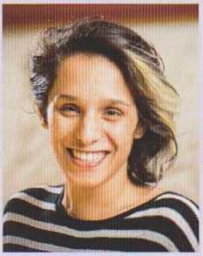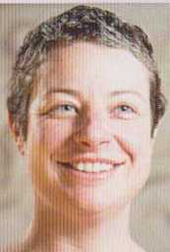

**Asma Ashraf, Research Nurse, Institute for Women's Health**

"Asma is the person who most helped me see that I could usefully support the work of female activists through my position and experience at the UCL Institute for Women's Health, even though I certainly do not consider myself an activist - I am but an academic!"

**Fiona Addison,**

**Volunteering Development Coordinator, UCLU**

"I've managed Fiona for almost 8 years and, throughout that time, have been inspired by her dedication, creativity and personable approach to work and to life. I know that many, many students have had their time at UCL transformed by her support."

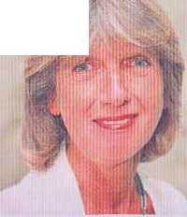**Jan Atkinson, Emeritus Professor, Division of Psychology and Language Sciences**

"Jan Atkinson is an impressive woman in science who worked her way up to a professorship at a time when women were severely underrepresented in psychology. Such a true scientist is an inspiration to all of us and shows us that research is not just a job but a calling."

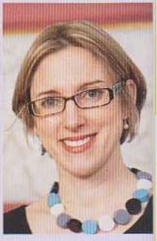**Sarah-Jayne Blakemore, Professor, Division of Psychology and Language Science**

"Sarah's lab was a revelation. She ran an innovative, inspiring research programme. At the same time she had a clear priority for family Sarah's example drastically changed my perspective. Where once I saw academic 'role models' bragging about inhumane hours, I now saw the opportunities that come with flexibility."'

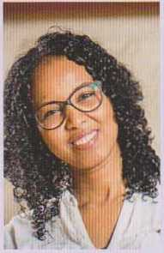

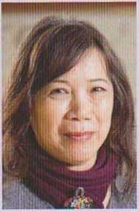

**Lai Fong Chiu, Principal Research Associate, UCL Energy Institute**

"Lai Fong has been a great mentor who, despite not formally supervising me, has always had an open ear and some encouraging words. Her enthusiastic and always curious nature has been a continuous inspiration to keep questioning the seemingly obvious and look deeper into the relation between the built environment and its occupants."

**Muna Elmi, Research Associate, Computer Science**

"Through Muna's hard work she has succeeded in her field and has given me confidence that I can achieve more than I have dreamt about (and I dream pretty BIG- Nobel prize BIG). I asked Muna to become my mentor and without hesitation she agreed. As a Somali student she stands as one of the very few Somali women I am able to see as a mirror to my future as a great scientist."

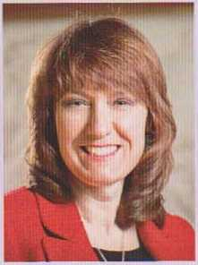

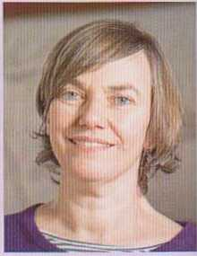

**Michele Farmer, Disability IT Support Analyst, Student Disability Services**

"Michele is a credit to her field. She is the sole point of contact for all staff and students across UCL who use or need assistive technology. I doubt that there is any part of UCL remaining untouched by her support and assistance."

**Louise Fryer, Teaching Fellow, SELCS**

"Since I met Louise I have always been inspired by her ability to combine her role as an academic and as a professional audio describer for the blind and partially sighted. I always admired the passion with which she approached her work, as well as her dedication to her field of expertise."