Statistics and Graphs

* Staff uptake (2008-present): 382% (of 2008 uptake)
* Staff uptake (last year-present): 112% (of last year's uptake)
* Student uptake (2008-present): 183% (of 2008 uptake)
* Student uptake (last year-present): 92% (of last year's uptake)

Staff Referral Origins Sept 2008 – Aug 20017

The above graph shows the 5 sources of access to the service by staff – UCL Main Occupational Health, Other Occupational Health, Safety Services, Direct Contact and Events. The primary source of contact is direct, which has increased the most year on year.

The following graphs show the access figures for the service by staff and students on a month by month basis.

Student General Contact Sept 2008 – Aug 2017

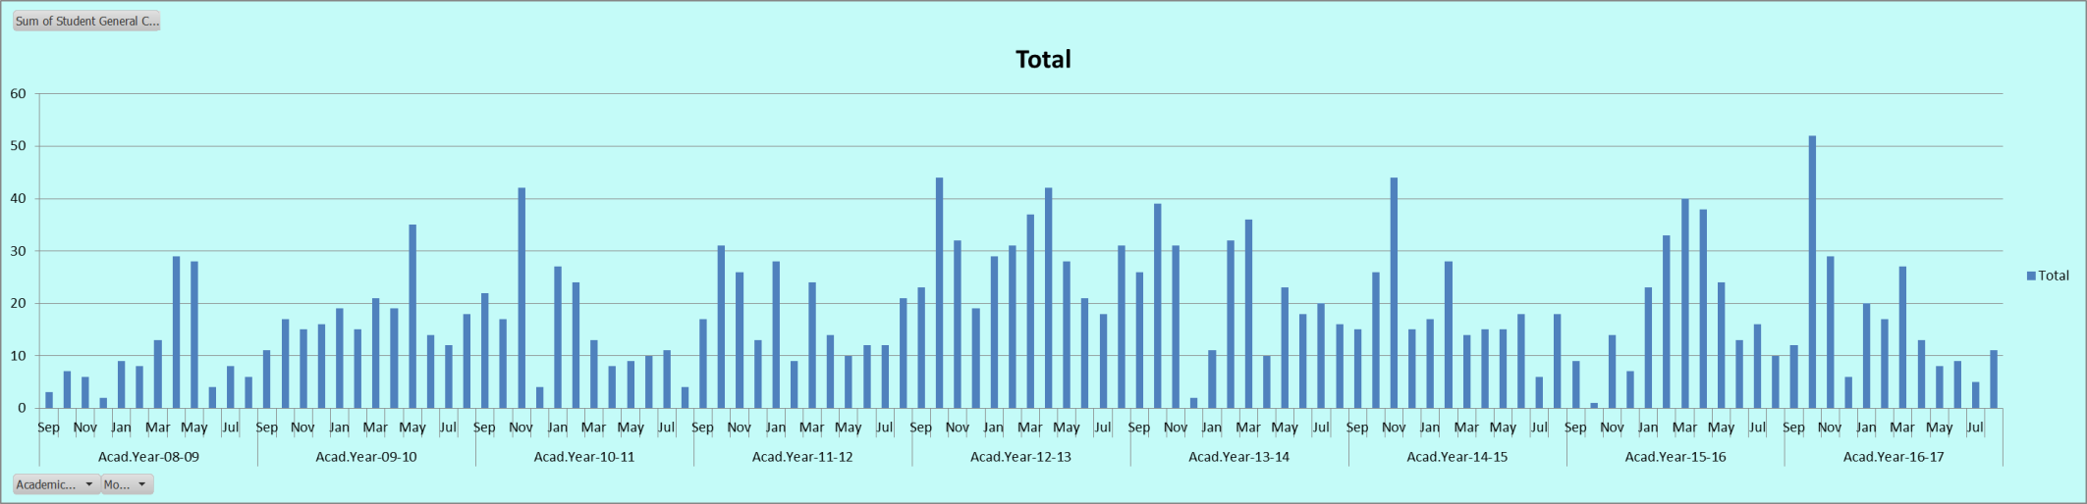

Student Induction Sept 2008 – Aug 2017

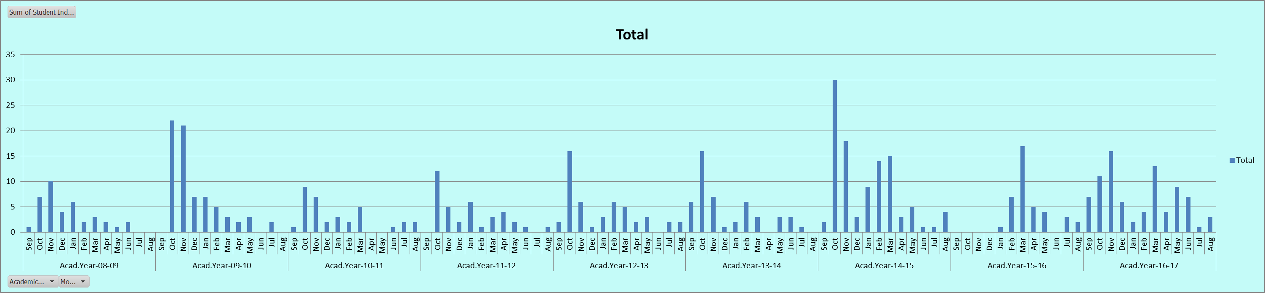

Student Training and Demo Sept 2008 – Aug 2017

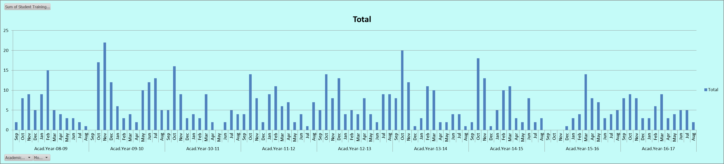

Staff Contact Sept 2008 – Aug 2017

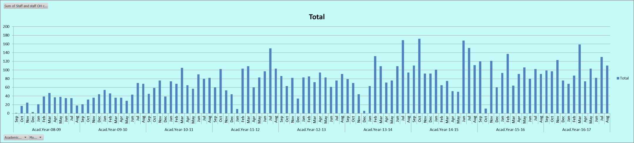

Staff Training Sept 2008 – Aug 2017

